XML Location Specific example

1. Paragraph content marking method in Word

* <ir:Paragraphs_In_WP xmlns:ir="http://document-identification-and-reference/2023" URL="file:///C:/Users/HP/Desktop/1.docx" begin="5" end="10"/>, said document (C:/Users/HP/Desktop/1.docx) in the fifth to the tenth paragraph.
* <ir:Paragraphs_In_WP xmlns:ir="http://document-identification-and-reference/2023" URL="file:///C:/Users/HP/Desktop/1.docx" begin="5" end="5"/>, said document (C:/Users/HP/Desktop/1.docx) in the fifth paragraph.
* <ir:Text_In_WP xmlns:ir="http://document-identification-and-reference/2023" URL="file:///C:/Users/HP/Desktop/1.docx" ><ir:Begin paragraph_number="1" text_pos="5"/><ir:End paragraph_number="3" text_pos="10"/></ir:Text_In_WP>, said document (C:/Users/HP/Desktop/1.docx) of paragraph 1 of the fifth character to the third paragraph 10 characters.

Example diagram:

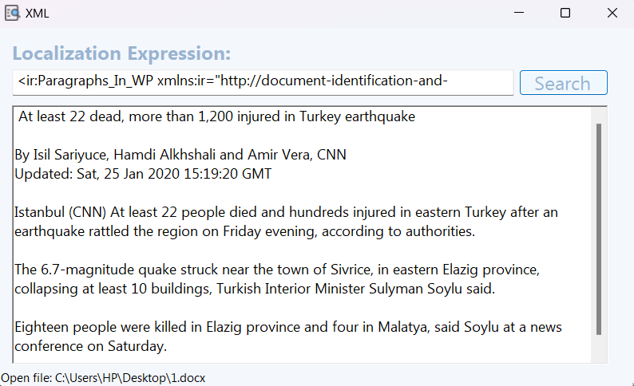

1. Table content marking method in Word

* <ir:Table_In_WP xmlns:ir="http://document-identification-and-reference/2023" URL="file:///C:/Users/HP/Desktop/test_table.docx" begin="1 " end="2"/>, means table 1 to table 2 in document (C:/Users/HP/Desktop/test_table.docx).
* <ir:Table_Text_In_WP xmlns:ir="http://document-identification-and-reference/2023" URL="file:///C:/Users/HP/Desktop/test_table.docx"><ir:Begin table_number="2" row_number="1"/><ir:End table_number="2" row_number="3"/></ir:Table_Text_In_WP>, represents rows 2 through 3 of the second table in the document (C:/Users/HP/Desktop/test_table.docx).
* <ir:Table_Text_In_WP xmlns:ir="http://document-identification-and-reference/2023" URL="file:///C:/Users/HP/Desktop/test_table.docx"><ir:Begin table_number="1" row_number="1" column_number="1"/><ir:End table_number="1" row_number="1" column_number="2"/></ir:Table_Text_In_WP>, represents columns 1 through 2 of row 1 of the first table in the document (C:/Users/HP/Desktop/test_table.docx).
* <ir:Table_Text_In_WP xmlns:ir="http://document-identification-and-reference/2023" URL="file:///C:/Users/HP/Desktop/test_table.docx"><ir:Begin table_number="1" row_number="1" column_number="2" p_number="1" text_pos="2"/><ir:End table_number="1" row_number="1" column_number="2" p_number="2" text_pos="3"/></ir:Table_Text_In_WP>, represents the second character of the first paragraph of the second column of the first row of the first table to the third character of the second paragraph of the second column of the first table in the document (C:/Users/HP/Desktop/test_table.docx).

Example diagram:

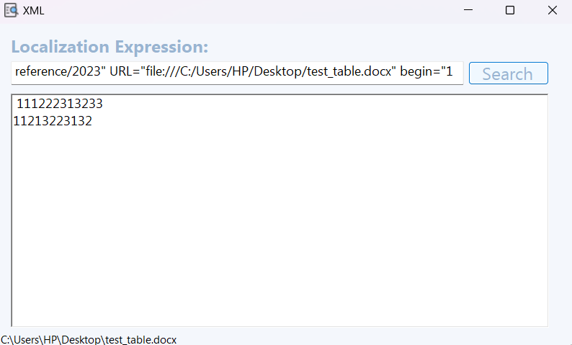

3. Cell content identification method in Excel

* <ir:Cell_In_SS xmlns:ir="http://document-identification-and-reference/2023" URL="file:///C:/Users/HP/Desktop/1.xlsx" sheet="111" begin="A1" end="A1"/>, means the cell at the intersection of column A and row 1 in the form named "111" in the document (1.xml).
* <ir:Cell_In_SS xmlns:ir="http://document-identification-and-reference/2023" URL="file:///C:/Users/HP/Desktop/1.xlsx" sheet="111" begin="A1" end="B2"/>, means the cell area between Column A and Column B and Row 1 and Row 2 in the form named "111" in the document (1.xml).

Example diagram:

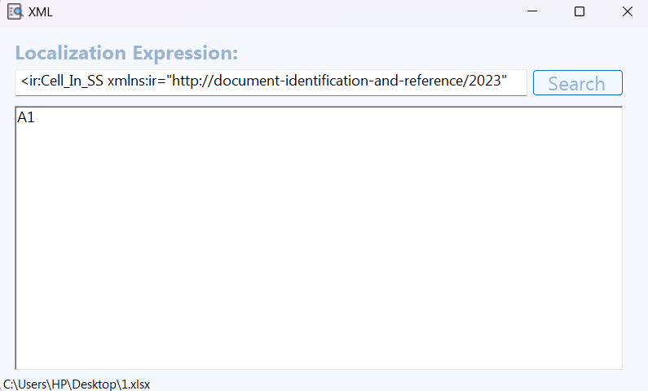

4. Slide Content Labeling Methods in PowerPoint

* <ir:Slide_In_Presentation xmlns:ir="http://document-identification-and-reference/2023" URL="file:///C:/Users/HP/Desktop/test.pptx" begin="1" end="4"/>, means slides 1 through 4 in the document (C:/Users/HP/Desktop/test.pptx).
* <ir:Slide_In_Presentation xmlns:ir="http://document-identification-and-reference/2023" URL="file:///C:/Users/HP/Desktop/test.pptx" begin="2" end="2"/>, means the 2nd slide in the document (C:/Users/HP/Desktop/test.pptx).

Example diagram:

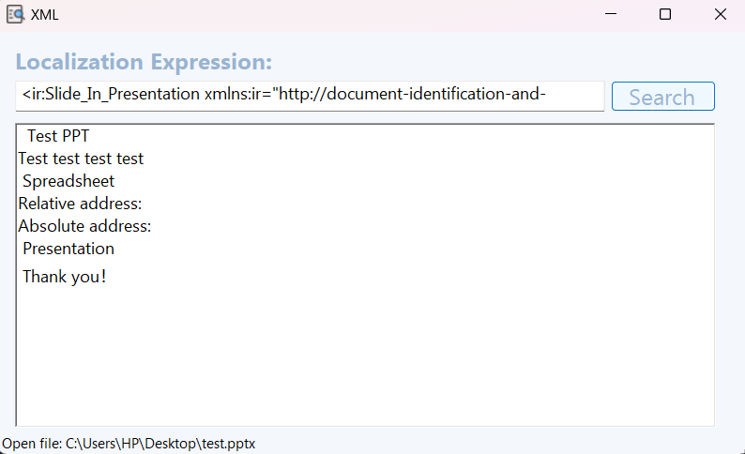

5. Object Content Identification Methods in Ofd

* <ir:Pages_In_FLD xmlns:ir=http://document-identification-and-reference/2023 URL="file:///C:/User/HP/Desktop/1_ofd.ofd" begin="0" end="1"/>, means page 1 to page 2 in the document (C:/Users/HP/Desktop/1.ofd).
* <ir:Object_In_FLD xmlns:ir="http://document-identification-and-reference/2023" URL="file:///C:/Users/HP/Desktop/test.ofd" ><ir:Begin page_number="0" object_pos="003"/><ir:End page_number="1" object_pos="010" /></ir:Object_In_FLD>, means the 3rd object on page 1 to the 10th object on page 2 of the document (C:/Users/HP/Desktop/1.ofd).

Example diagram:

